Lecture 3.

**Differential equations. Basic definitions. Initial condition.**

**Differential Equations of the 1-st order.**

**Equations with separated variables**

**1. Differential equations. Basic definitions.**

*In this section we will introduce some basic terminology and concepts concerning differential equations. We will also discuss the general idea of modeling with differential equations, and we will encounter important models that can be applied to chemistry, ecology, and physics. In later sections of this chapter we will investigate methods that may be used to solve these differential equations.*

***A*** ***differential equation*** is an equation involving one or more differential equation order derivatives of an unknown function.

. (1)

In this section we will denote the unknown function by *y* = *y(x)* unless the differential equation arises from an applied problem involving time, in which case we will denote it by *y* = *y(t)*.

The ***order*** of a differential equation is the order of the highest derivative that it contains.

For example,, *, * are first-order differential equations; ** is second-order differential equation;  is third-order differential equation.

A function is a ***solution*** of a differential equation (1) on an open interval if the equation is satisfied identically on the interval when *y* and its derivatives are substituted into the equation.

For example,  is a solution of the differential equation

 (2)

since substituting *y* and its derivative into the left side of this equation yields

.

The graph of a solution of a differential equation is called an ***integral curve*** for the equation, so the general solution of a differential equation produces a family of integral curves corresponding to the different possible choices for the arbitrary constants. For example, Figure 1 shows some integral curves for (2), which were obtained by assigning values to the arbitrary constant in .

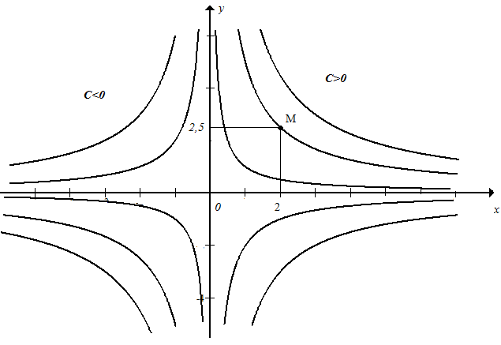

***Figure 1***

**Initial-value problems.** When an applied problem leads to a differential equation, there are usually conditions in the problem that determine specific values for the arbitrary constants. As a rule of thumb, it requires *n* conditions to determine values for all *n* arbitrary constants in the general solution of an *n*th-order differential equation (one condition for each constant).

, , , ...

For a first-order equation, the single arbitrary constant can be determined by specifying the value of the unknown function *y(x)* at an arbitrary *x*-value *x*0, say *y(x*0*)* = *y*0. This is called an ***initial condition***, and the problem of solving a first-order equation subject to an initial condition is called a ***first-order initial-value problem***. Geometrically, the initial condition *y(x*0*)* = *y*0

has the effect of isolating the integral curve that passes through the point *(x*0*, y*0*)* from the complete family of integral curves.

***Example 1*.** The solution of the initial-value problem

, .

can be obtained by substituting the initial condition  in the general solution  to find *C*. We obtain



Thus, *C* = 5, and the solution of the initial-value problem, which is obtained by substituting this value of *C* in general solution, is  Geometrically, this solution is realized as the integral curve in Figure.1 that passes through the point .

***Example 2*.** **Uninhibited population growth**. One of the simplest models of population growth is based on the observation that when populations (people, plants, bacteria, and fruit flies, for example) are not constrained by environmental limitations, they tend to grow at a rate that is proportional to the size of the population—the larger the population, the more rapidly it grows.

To translate this principle into a mathematical model, suppose that y = y(t) denotes the population at time t . At each point in time, the rate of increase of the population with respect to time is dy/dt, so the assumption that the rate of growth is proportional to the population is described by the differential equation



where *k* is a positive constant of proportionality that can usually be determined experimentally.

Thus, if the population is known at some point in time, say *y* = *y*0 at time *t* = 0, then a formula for the population *y(t)* can be obtained by solving the initial-value problem

 , 

***Example 3*.**  **Pharmacology**. When a drug (say, penicillin or aspirin) is administered to an individual, it enters the bloodstream and then is absorbed by the body over time. Medical research has shown that the amount of a drug that is present in the bloodstream tends to decrease at a rate that is proportional to the amount of the drug present - the more of the drug that is present in the

bloodstream, the more rapidly it is absorbed by the body.

To translate this principle into a mathematical model, suppose that *y* = *y(t)* is the amount of the drug present in the bloodstream at time *t* . At each point in time, the rate of change in *y* with respect to *t* is *dy/dt*, so the assumption that the rate of decrease is proportional to

the amount *y* in the bloodstream translates into the differential equation



where *k* is a positive constant of proportionality that depends on the drug and can be determined experimentally. The negative sign is required because *y* decreases with time. Thus, if the initial dosage of the drug is known, say *y* = *y*0 at time *t* = 0, then a formula

for *y(t)* can be obtained by solving the initial-value problem

 , 

2. **FIRST-ORDER SEPARABLE EQUATIONS**

In this section we will discuss a method, called “separation of variables,” that can be used to solve a large class of first-order differential equations of a particular form.

. (1)

Such first-order equations are said to be ***separable***. The name “separable” arises from the fact that Equation (1) can be rewritten in the differential form

 (2)

in which the expressions involving *x* and *y* appear on opposite sides. The process of rewriting (1) in form (2) is called ***separating variables***.

We have the following procedure for solving (1), called ***separation of variables***:

**Step 1.** Separate the variables in (2) by rewriting the equation in the differential form:



**Step 2.** Integrate both sides of the equation in Step 1 (the left side with respect to *y* and the right side with respect to *x*):

.

**Step 3.** If *H(y)* is any antiderivative of right sideand *G(x)* is any antiderivative of left side, then the equation

*H(y)* = *G(x)* + *C*

will generally define a family of solutions implicitly. In some cases it may be possible to solve this equation explicitly for *y*.

**Example 1**. Solve the differential equation



***Solution***. We can write the differential equation in form (1) as

**.**

Separating variables and integrating yields:

**.**

 or *lny+lnx=lnC.* Solving for *y* as a function of *x*, we obtain .

Some integral curves and our solution of the initial-value problem are graphed in Fig-1.